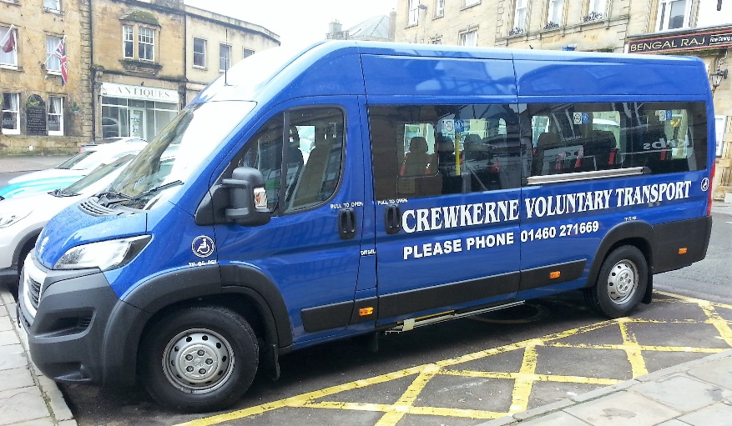
Can you Help?

Crewkerne Welfare Transport is in great need of volunteer drivers for our 16 seater mini – bus.
You may have spotted us around the town taking residents to the Henhayes Centre, picking up shoppers from outside Waitrose on a Thursday or taking school children to and from the local schools to activities elsewhere.
We do regular short runs every week and, during the summer months, longer day trips for local groups and organisations. We particularly need a driver/drivers for Monday mornings for the Henhayes run.
If you have a current regular driving licence and think you could help, or if you would like further information, ring 01460 271669 or email crewkernevoluntarytransport@gmail.com

