Distance: 2 ½ miles
Circular Walk East of Town
Time: 1 ¼ hours
Description: Easy walk along Town and Country paths. One steep ascent. stiles.
Start/End: Market Square.
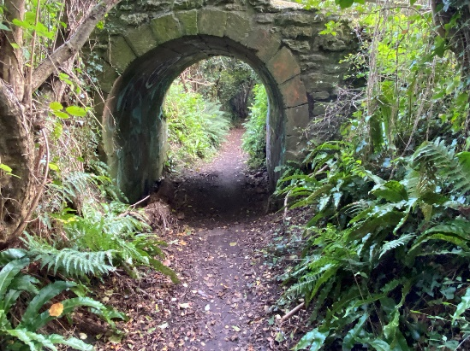
From Market Square cross the road to the George Hotel and turn left.
Walk along East Street to the pedestrian crossing and turn right into the footpath and walk down.
At the end of the footpath join the road through the industrial estate keeping to the left side ( Blacknell Lane ) towards the main road (South Street ). Very busy main road- take care.
Turn left along the main road. About 200 yards past the filling station turn left over a stile onto a footpath signed ‘to Easthams Lane’.
Straight ahead keeping under the hedge to the right pass through gateway into second field, the straight ahead towards gate in fence. Through gateway, cross bridge over stream, over the stile and turn right. Continue straight ahead through gateway and turn left.
Follow path up the hill, keeping to the hedge on left.

Look behind and admire the view to the south.

Over the two wooden stiles at the top of the hill and turn left onto the concrete driveway.
After 80 yards turn left into footpath between hedges and continue until path turns sharp right. Do not turn right but keep straight ahead through gateway and into field. Walk along the side of the field keeping under the hedge on the left.
Exit field on footpath and after 10 yards bear left down steps. Over the old iron stile and straight ahead down hill to concrete bridge. Do not cross the bridge but turn left and follow path through squeeze gate. Turn sharp right along sunken path, passing under the concrete bridge.
This lane is the ancient route from Crewkerne to North Perriott.
Follow footpath until it enters tarmac road (East Street-A30) at the pedestrian crossing. Extremely busy road-please take care.
Turn left and walk along the pavement to Market Square.

Please note construction works at Easthams Lane may affect that section of this walk.

