Circular Walk Around Crewkerne
Distance: 5 miles Time: Approximately 3 hours Start/End in Market Square
Description: Town and country paths. Some steep ascents/descents, tendency to mud in some places
Moderate/Difficult.
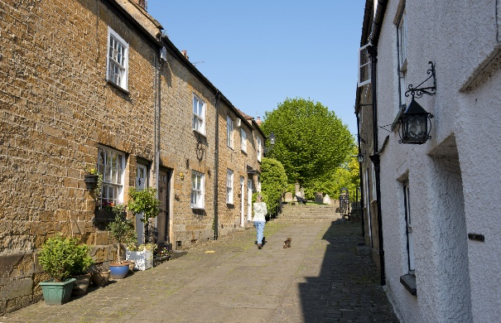
With your back to the Town Hall leave Market Square via Church Street on the right. Continue up the steps into the churchyard and take the first left (Church Path) into Gouldsbrook Terrace. Turn right and cross the road to the pavement on the opposite side.
- Continue along the pavement to the main road (West Street) Cross road with caution to Crewkerne Community Church. Turn into Barn Street on your right. Take the third left (Curriott Hill Road) and follow until you meet the main
road (B3165) Very Busy road – please take care.

- cross over the road and enter the field. Follow the footpath straight ahead.

Note the excellent view on your right of Henley Manor and Toller Down.

- Continue along this path around the side of the hill then bear right d9own to the valley bottom passing through a pair of gates.

- Follow the valley, keeping to stream on right and through the gate.. Turn right across stream by wooden bridge and stile. Turn right, up through gap in the hedge. Keep the upper boundary hedge on your left until you reach a gate and stile. Cross the stile into lane and continue to the main road. Cross the A356 with extreme care

If you are in need of refreshment a slight detour to the right is Crewkerne Station where you will find Sue’s Café.

- Turn right towards Crewkerne. Just past Hellings Farm turn right over a stile onto the track signed ‘Easthams Lane’

- Straight ahead, alongside the new housing estate, keeping under the hedge to the right pass into field, then cross stream over the bridge, over stile and turn right. Continue straight ahead through gateway and turn left.

- Follow path up hill keeping to hedge on left

- Good view behind you of the Parrett and beyond

- At the top of the hill turn left onto concrete driveway. After 80 yards turn left into footpath between the hedges.

- Keeping hedge on the left continue straight on. The Town cemetery is on the right. Pass through the kissing gate on to the main A30
At this point you can turn left and follow the pavement back to the Town Hall.
- To continue the walk cross the road with extreme care, Turn right and first left into Ashlands Road. After 20 yards cross Ashlands Road and into track. Almost immediately turn left into track and follow behind houses. At T junction keep left again keeping behind houses to Ashlands Road following the pavement; just past Oak Drive turn right into track (Longstrings Lane)

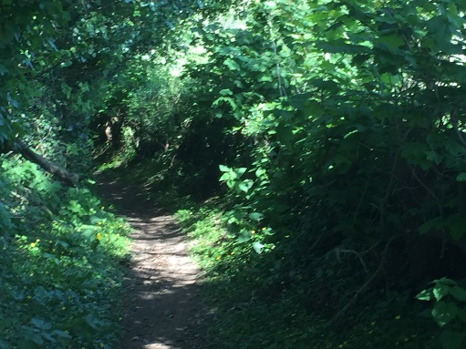
- At the T- junction of lane & track take the left fork, the path
bends to the right and drops down to the main road (A356
from Crewkerne)

- Cross road with caution. Turn left towards Crewkerne and
follow the pavement

- Turn right onto concrete farm track (Haymore Farm). Bear left and them immediately left onto path behind houses, through the rambler gate and up to top left-hand corner of the field.

- Pass through the gate into the lane (Crow Castle Lane). Ignore the gate on the left. At the fork in the path bear left. to metalled road (Hinton Road). Cross over to lane opposite (Saunders Piece Lane) At the junction of four tracks turn left through the squeeze gate, leading to open fields. Continue down through Bincombe Valley.

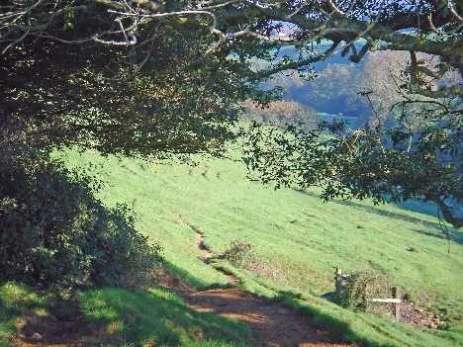
As you go down stop to admire the wonderful view of the valley and the west front of the church

- Through the gate in the iron fence. Walk straight ahead towards the church tower and through the kissing gate. Follow the track between the mill buildings and up the steps to the churchyard.

- Take the left path around the church and exit into Abbey Street by the Church Hall. Walk right towards
Market Square

Please Note: The various Construction sites around the Town may mean that the footpaths have been diverted.

Look out for local signage

