Circular Walk South of Town
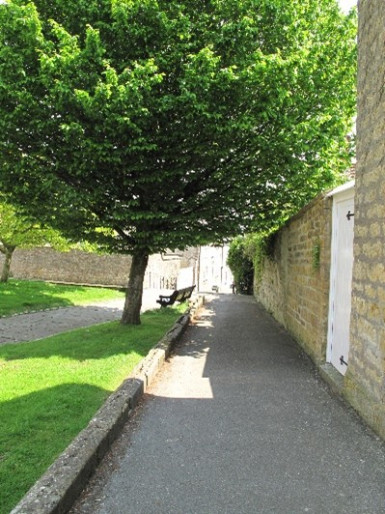
Distance: 2 miles Time: Approximately 1 ¼ hours Start/End in Market Square
Description: Moderate walk along town and country paths. 3 stiles

With your back to the Town Hall leave market square via Church Street on the right. Continue up the steps into the churchyard and take the first left (Church Path) into Gouldsbrook terrace. Turn right and cross the road at the rectory to the pavement on the opposite side. Continue along the pavement to the main road (West Street). Very busy road (A30)-please take care.

- Cross West Street to Crewkerne Community Church. Turn right, across Barn Street, and into the road dropping down to the left (Lyewater).
- After 100 yards take the footpath to the left and follow the stream. After a further 100 yards turn left, follow mown path until you reach a flight of wooden steps leading to Barn Street. Turn right.
Note the Tythe Barn conversion on the right.
- Take the first turning left (Tower Hill Road). Continue to end of road and turn right (Middle Path) passing the Health Centre. Continue until you reach the roundabout. Busy road – please take care.
- Cross the roundabout and continue straight ahead. (Severalls Park Avenue).
Note the avenue of trees leading to the war memorial. These were planted as a memorial to the Crewkerne servicemen killed in World War 1.
- Almost immediately turn right into pathway leading to Lang Road.
Note Blue Plaque on left as you turn into pathway.
- Bear left and ignoring all turnings continue to the crossroads. Cross over and continue until you see the T-junction with Cathole Bridge Road. Ten yards before reaching the junction cross over the wooden stile to the left and follow the footpath straight ahead.
Note the excellent view on your right of Henley Manor & in the distance Toller Down.
- Continue on the path along the side of the hill and then bear right down to the valley bottom and cross over the stile.
- Keeping the stream on the right, follow the valley over a wooden stile and into a narrow enclosed footpath. At the end of the footpath turn left (Shute Lake Lane) and to the junction (Kithill).
Note old sailcloth factory on the right.
- Cross straight over Kithill and enter a fenced walk-way between the houses leading into a cul-de-sac (Thomson Drive). At the end of Thomson Drive the road joins South Street (A£%^). Very busy road-take care.
- Cross over the main road and turn left. Walk along the pavement and turn right into footpath opposite the police station. Continue straight ahead, crossing over roadway, along footpath out into East Street at pedestrian crossing. Main A30 – very busy road. Extreme caution.
- Turn Left and walk along the pavement to Market Square where walk ends.

Please note: The various construction sites around the town may mean the footpaths have been diverted. Look out for local signage

