Circular Walk Around Crewkerne
Distance: 5 miles Time: Approximately 3 hours Start/End in Market Square
Description: Town and country paths. Some steep ascents/descents, tendency to mud in some places
Moderate/Difficult.
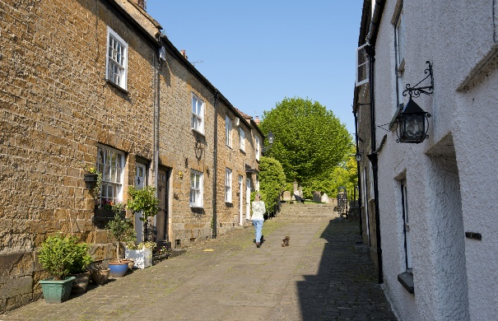
With your back to the Town Hall leave Market Square via Church Street on the right. Continue up the steps into the churchyard and take the first left (Church Path) into Gouldsbrook Terrace. Turn right and cross the road to the pavement on the opposite side.
- Continue along the pavement to the main road (West Street) Cross road with caution to Crewkerne Community Church on left side of Barn Street. Walk up to third left (Curriott Hill Road) and follow until you meet the main road (B3165) Lyme Road.
Very Busy Road – please take care).
- Cross Road and take first left in Lang Road. Continue up incline and straight ahead at crossroad. Ignoring all turnings, continue to the crossroads. Just prior to the T junction with Cathole Bridge Road, turn left into field at footpath sign, and continue past footpath post, straight ahead.

Note the excellent view on your right of Henley Manor and Toller Down.
- Continue along this path around the side of the hill, then bear right as path forks left down a short steep descent, with rail track on the right, to the valley bottom, passing through in close proximity: first a squeeze and then a rambler gate in the hedge.

- Follow the path straight along the left side of the valley, keeping the stream to the right and eventually bear right towards the stream and through a kissing gate under the trees, to the left, ignoring the gate on the right), Turn right across stream by wooden bridge and broken stile. Turn right, up the incline and through gap in the hedge. Keep the upper boundary hedge on your left until you reach a gate and stile. Cross the stile into lane and continue to the metal gate to the main road (Station Road) Cross the A356 with extreme care

If you are in need of refreshment a slight detour to the right is Crewkerne Station where you will find Sue’s Café.

- Otherwise turn left towards Crewkerne with the Stagecoach Inn on the right and continue for about 500 yards. Just past Hellings Farm turn right at the new footpaths post, with the new housing estate and road on the left. Straight ahead on foot path keeping hedge on right for about 500 yards, to bear right, then a sweeping left curve around newly created drainage ponds, before eventually bearing right to follow path up hill, keeping the hedge on the left..

- Straight ahead, alongside the new housing estate, keeping under the hedge to the right pass into field, then cross stream over the bridge, over stile and turn right. Continue straight ahead through gateway and turn left.

Good view behind you of the Parrett and beyond

- At the top of the hill turn left onto concrete driveway. After about 80 yards turn left into signposted footpath between the hedges.

- Continue straight on past a gap in the hedges. The Town cemetery is on the right. Pass through the kissing gate and follow path to a metal gate on to the main A30
At this point you can turn left and follow the pavement back to the Town Hall.
- To continue the walk, cross the road with extreme care. Turn right and first left onto footpath after Ashlands Road. Behind houses with the hedge on the left and the new Goldwell Farm building site on the right. At T junction keep left again keeping behind houses returning to Ashlands Road joining the pavement straight ahead. following the pavement. Just past Oak Drive turn right into track (Longstrings Lane)
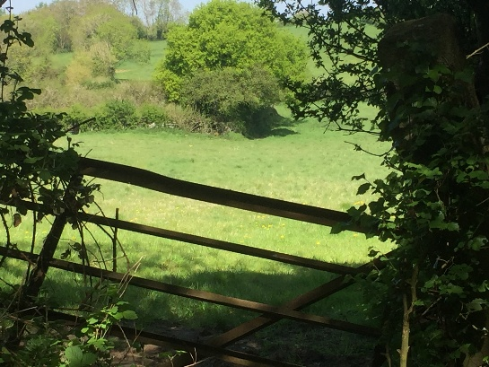

- At the T- junction of lane & track take the left fork, the path
bends to the right and drops down under trees to the main road (A356 from Crewkerne)

- Cross road with caution. Turn left towards Crewkerne and
follow the pavement downhill

- At the footpath post turn right onto road towards Haymore Farm. Bear left and them immediately left onto sign-posted path behind houses on the left through the rambler gate and up to top left-hand corner of the field.

- Pass through the rambler gate into the lane (Crow Castle Lane). Ignore the gate on the left. At the fork in the path bear left. to metalled road (Hinton Road). Cross over to lane opposite (Saunders Piece Lane) Continue uphill ignoring various farm agates, until before At the junction of four tracks. With two chained gates on left, turn left down slope and through squeeze gate, leading to open fields. Continue down through Bincombe Valley.

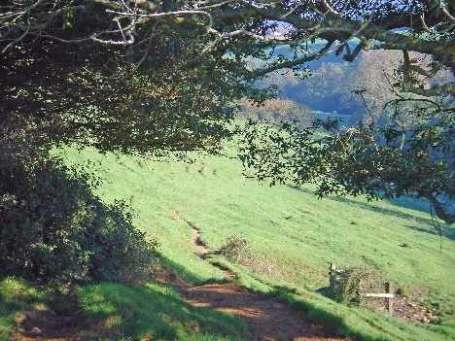
As you go down stop to admire the wonderful view of the valley and the west front of the church

- Through the rambler gate in the fence. Walk straight ahead towards the church tower and through the kissing gate. Follow the track between the mill buildings and up the steps to the churchyard.

- Take the path left around the church and exit right into Abbey Street by the Church Hall. Walk right towards
Market Square

