Distance: 2 ½ miles
Circular Walk East of Town
Time: 1 ¼ hours
Description: Easy walk along Town and Country paths. One steep ascent. stiles.
Start/End: Market Square.
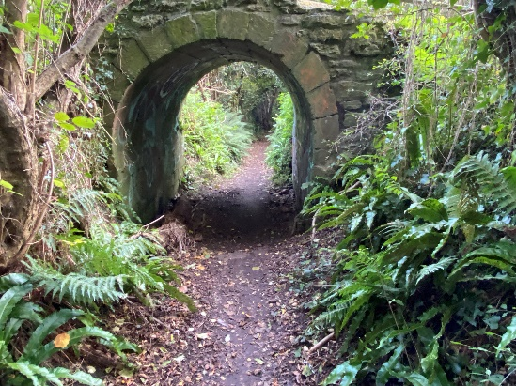
From Market Square cross the road
to the George Hotel and turn left.
Walk along East Street to the pedestrian crossing and turn right
into the footpath and walk down.
At the end of the footpath join the road through the industrial estate keeping to the left side (Blacknell Lane) towards the main road (South Street). Very busy main road- take care.
Turn left along the main road. About 200 yards past the filling station and the new housing estate and road, turn left at the signed footpath. Straight ahead keeping hedge on the right for about 500 yards, to bear right, then a sweeping left curve around the newly created drainage ponds, before eventually bearing right to follow path up hill, keeping to the hedge on left.
Look behind and admire the view to the south.
At the top of the hill and turn left onto the concrete driveway.
After about 80 yards turn left into signposted footpath between hedges. Continue straight on to a gap in the hedges and turn left down the descending footpath, bearing right to a gap in the hedge. Turn sharp right along sunken path passing under concrete bridge.
This lane is the ancient route from Crewkerne to North Perrott.
Follow footpath until it enters tarmac road (East Street-A30) at the pedestrian crossing.
Extremely busy road-please take care.
Turn left and walk along the pavement to Market Square.

